How do I change the GAAM Endpoint User?

As a prerequisite, the Goliath Application Availability Monitor (GAAM) Endpoint, requires a user with Windows administrative rights on the machine to be in active or disconnected state to the machine. This account is the one which initially ran the GAAMEndpoint.exe installer file. To change the user how is tied to the LogonSimulator.exe process, please follow the below steps. If you are unsure of the account see article [How do I determine which account is running as the GAAM Endpoint User?](https://support.goliathtechnologies.com/hc/en-us/articles/10063462397463)

1. Connect to the GAAM Endpoint as the **current** user who is running LogonSimulator.exe
2. Open **Task Manager** and end the LogonSimulator.exe process. Once complete, Task Manager can be closed.
3. Right click the **Windows Start Menu** and select the **Run** program
4. In the Run program window, enter **shell:startup** and click OK
   1. 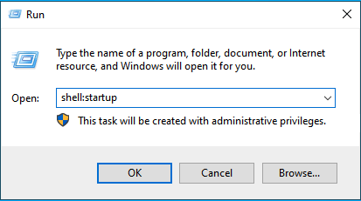
5. A **Windows File Explorer** window will open to the current users startup folder. The file **LogonSimulator.exe** should be listed. If so, please select the file and delete it. If not, proceed to the next step.
   1. 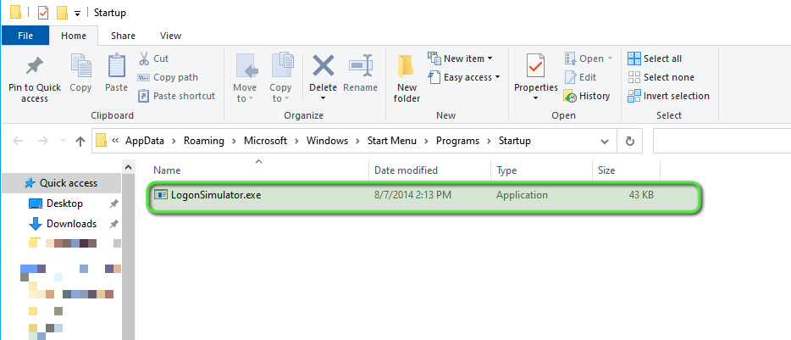
6. Close the Windows File Explorer window and logoff of the GAAM Endpoint.
7. Connect to the GAAM Endpoint as the **new** user and complete the steps in the [Launch Endpoint Installation & Configuration](https://support.goliathtechnologies.com/hc/en-us/articles/360024769993) article.